5-17 Markdown

Original data output by experiment. Correct: Participant made the correct (1) prediction or wrong (0) prediction winner: which horse won (1 or 2) hi/lo: high-calibrated vs low-calibrated advisor Conf: high confidence prediction (1) vs low confidence prediction (0) Rslt: advisor made the correct (1) prediction or wrong (0) prediction

## # A tibble: 4,350 x 10  
## subID trialNum cntBalance correct rt winner hiConf loConf hiRslt loRslt  
## <chr> <int> <chr> <int> <dbl> <int> <int> <int> <int> <int>  
## 1 0uk 1 L 1 4981 1 1 1 1 1  
## 2 0uk 2 L 1 3162 2 1 1 1 1  
## 3 0uk 3 L 0 2632 1 1 1 1 0  
## 4 0uk 4 L 1 1705 2 1 0 1 0  
## 5 0uk 5 L 1 1734 2 1 0 1 1  
## 6 0uk 6 L 0 1558 2 1 1 1 0  
## 7 0uk 7 L 0 3964 2 0 0 0 0  
## 8 0uk 8 L 1 1960 2 0 1 1 1  
## 9 0uk 9 L 0 1221 1 0 1 1 0  
## 10 0uk 10 L 0 1822 1 1 0 0 1  
## # ... with 4,340 more rows

Plots of advisor confidence over 500 trials for four sample participants

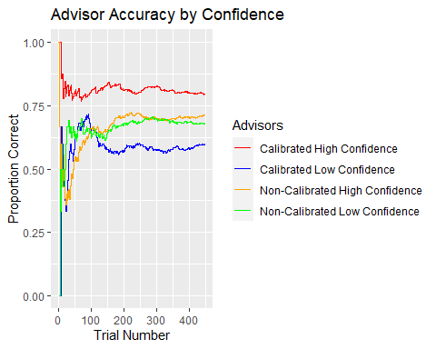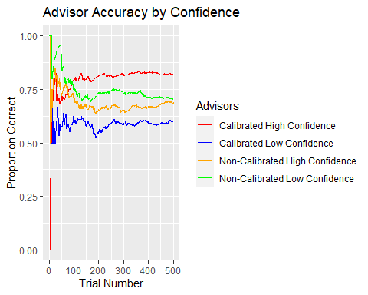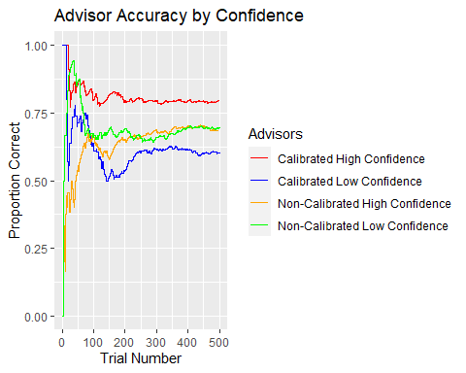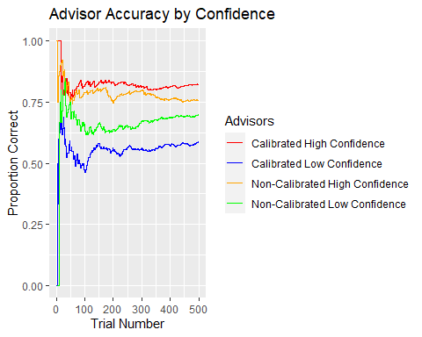

Tables & Plots for participant agreement with advisors Table 1. Proportion of trials which each participant agreed with one of the two advisors when both advisors gave different responses (disagree) Table 2. Number of participants that agreed with one of the two advisors for the majority (<.5) of trials Figure 1. Boxplot of agreement data

## # A tibble: 9 x 10  
## subID disagree HH HL LL LH H_HH H_HL H_LH H_LL  
## <chr> <int> <int> <int> <int> <int> <dbl> <dbl> <dbl> <dbl>  
## 1 0uk 186 52 37 41 56 0.538 0.595 0.5 0.561  
## 2 aya 214 50 48 53 63 0.74 0.792 0.635 0.717  
## 3 bsp 186 39 38 52 57 0.359 0.789 0.228 0.423  
## 4 btm 222 50 49 55 68 0.64 0.735 0.397 0.655  
## 5 f88 207 43 45 55 64 0.791 0.956 0.0938 0.291  
## 6 ga4 178 40 47 50 41 0.825 0.979 0.0244 0.9   
## 7 ht1 205 51 39 55 60 0.431 0.974 0.0667 0.4   
## 8 pj7 208 68 41 43 56 0.426 0.829 0.161 0.326  
## 9 ynb 210 42 57 60 51 0.571 0.491 0.471 0.467

## # A tibble: 12 x 3  
## value one two   
## <int> <chr> <chr>   
## 1 6 High High vs High  
## 2 8 High High vs Low   
## 3 1 High Low vs High   
## 4 4 High Low vs Low   
## 5 0 None High vs High  
## 6 0 None High vs Low   
## 7 1 None Low vs High   
## 8 0 None Low vs Low   
## 9 3 Low High vs High  
## 10 1 Low High vs Low   
## 11 7 Low Low vs High   
## 12 5 Low Low vs Low

